**Car Prices are increasing at a higher rate as compared to Income**

**Abstract**

The automobile industry has a fundamental impact on the economic activity in United States and world. The global automotive industry is estimated to grow just under 9 trillion dollars by 2030 and new vehicle sales will account for 38% of this value. Acknowledging the fact that US automotive market is one of the largest, in this paper we will explore the US market characteristics focusing on the demand with other explanatory variables.

Previous studies had been conducted using the different models and variables, however some of them used non recent time periods. The purpose of this study is to investigate key aspects of the US automobile market and give a pretext for more exhaustive studies of recent issues. Our main objective is to understand the relationship between the prices and the disposable income. This is done using monthly data from 2005 to 2020 and developing a time series Vector Error Correction Model.

The paper is organized as follows – 1) Exploration of Variables 2) Estimation of Model and Price Elasticities 3) Describing general market landscape and its main issues and concerns.

In our study we have used lagged explanatory variables to understand the long run relationship and from our study we found that the Average auto price is not an important factor for the shift in the demand function (as many previous studies depict) and the disposable income is proportionally related to the demand.

From our model in the long run, price elasticity is inelastic that means the reaction of the demand is relatively unresponsive to the changes in price.

Our main premise was that the price grow rate is greater than the disposable income grow rate, and this would lead to decrease in the demand. Even if the price is not significant in our model so further research should be conducted in order to understand this relationship better and investigate the role of interest rates and loans.

**Chapter 1**

**Introduction**

**General Landscape**

“In 2018, motor vehicles and parts accounted for $521.5 billion of the $20.58 trillion in total U.S. GDP. This translates to 2.5%. The U.S. automotive sector employs over 2.8 million people and pays around $130 billion in annual compensation.7﻿ Thus, its human resources also have a big impact on the economy. Since the first automobile, auto manufacturing has grown to become a substantial contributor to the U.S. economy with General Motors, Ford, and Fiat Chrysler rounding out the big three. The Organisation Internationale des Constructeurs d’Automobiles (OICA) ranks the United States as the second-largest producer of automobiles, second only to China in the number of motor vehicles produced per year.

Automobile industry of US was flooded with foreign automobile companies especially those of Japan and Germany after the world war II. Infact, as the developed market are getting saturated and thanks to globalisation, the world auto industry is focussing on the developing market such as South America.

The US ranks 3rd in the world with 331 million people of which 82% is urbanised. In the recent years population is growing with a slow rate. The growth of the population leads to increase in the urban areas and the technology has augmented the road spreads and consequently miles travelled per person has significantly increased.

Automobiles, being a durable commodity, have some of the properties of both consumer and investment goods. Through depreciation an owner does consume his purchase, but he is also making a significant investment in future transportation services. Since automobiles are not alike and consumers do not always buy them for the same reasons. It introduces dynamics into both producers’ output decisions and consumers’ purchase decisions in the automobile market, which creates challenges for both theoretical and empirical work.

As the general landscape of the competition, even though there are several companies of all sizes the domestic automotive industry can be approximated with an oligopoly characterised by three main large manufacturers, high entrance cost and high prices. Usually, the companies behave like a single monopolist and this leads to the result that the collusive price is way above the marginal cost.

The North American motor vehicle market remains the most open major market in the world, and thus, it is the target market for foreign manufacturers who wish to expand or shift production. Now a days, continuous disruption is emerging from new technologies such as electric vehicles and complementary products like software.

**Problems**

As prices for new vehicles continue to rise, the cost of an average new car may be a stretch for typical households. A new analysis from Bankrate.com found that a median-income household could not afford the average price of a new vehicle in any of the 50 largest cities in the country, though cars are more affordable in some cities than others.

“The new reality is that cars are becoming more expensive,” said Steve Pounds, a personal finance analyst for Bankrate. “People are having to make tough decisions about financing. “The average price of a new car or light truck in 2016 is about $34,000, according to Kelley Blue Book. That is in part because new cars are loaded with helpful but expensive safety features like collision-avoidance systems.

Bankrate calculated an “affordable” purchase price for major cities, using median incomes from United States census data, and factoring in costs for sales taxes and insurance. In San Jose, Calif. — the heart of Silicon Valley — the median income is about $84,000, and an “affordable” new car purchase price is about $33,000 — close to, but still below, the average new car price. While, in lower-income cities, however, affordable purchase prices for a typical family are far below the average cost of a new car. In Hartford, Conn., where the median income is about $29,000, an affordable purchase price is about $8,000 — about a quarter of the average new-car price.

Disposable income is the amount of money that an individual or household must spend or save after income taxes has been deducted. The average disposable income growth from 2005 is 2% while the car price growth is about 4%. Despite the average income is higher than the average car price, people need to account for necessities such as food, water, electricity etc if we consider the remaining part, deducted a percentage for savings, is not enough to buy a new vehicle in most households.

That sort of squeeze helps explain why many people are borrowing more, for longer periods of time, to finance a car purchase. Experian Automotive said that in the first quarter of 2016, the proportion of new cars bought with the help of financing rose to more than 86 percent, and the average loan amount topped $30,000, which is the highest since Experian began tracking the data. The average term for a new-car loan is now 68 months — about five and a half years — and some loans stretch as long as seven years. As a result, people have taken auto loans with longer term, which means they are in debt for years and end up paying more in interest over time.

(Auto leases are also becoming more popular because they often offer lower payments than a traditional car loan. Leases accounted for more than 30 percent of new-car transactions in the first quarter, Experian reported. With a lease, the customer makes payments for a set period of time, then typically can choose either to return the car to the dealer or to buy it.)

The purpose of this paper is to lay the foundation for further studies to tackle the problem of new passenger vehicles affordability, the rising of interest rate, other forms of purchase methods (leasing and long-term rent) and the possible policy issues such as Environment, Congestion, Investment and Regulations.

In section 2, we will investigate each variable searching for preliminary information and understanding the relationship between the variables.

In section 3, we will present the first attempt to build a model based on past literature but considering new factors and using recent data.

In section 4, we will explain considerations and implications of our study as well as its limitations.

In section5, we will state our conclusions.

**Chapter 2**

**Data Description & Analysis**

We have collected data in the form of Time Series at US state level from Federal Reserve Bank of St. Louis (which organize and clean the data from Bureau of Statistic & Transportation) monthly from year 1967 to 2020.

**Sales**

The variables collected are following –

* Domestic Auto Sales
* Foreign Auto Sales
* Domestic Light Truck Sales
* Foreign Light Truck Sales

We considered only the private passenger cars which include the auto and light truck vehicles. Both variables are collected for domestic and foreign producers’ sales as we wanted to capture possible trends in the different categories.



G1. Sales Volume by categories

From the graph G1, we can see that both Domestic and Foreign Auto Sales are declining while the domestic light truck sales and foreign light truck sales are increasing. Bearing in mind the general economic situation of the industry, this trend could reflect that the preference of the consumer is changing towards the light trucks because their utility is greater than automobiles (especially for household that can afford only one vehicle). We can also see that Foreign Sales have bigger impact on the total sales compared to the past.

We created the variable Total Auto Sales as the sum of several sales.

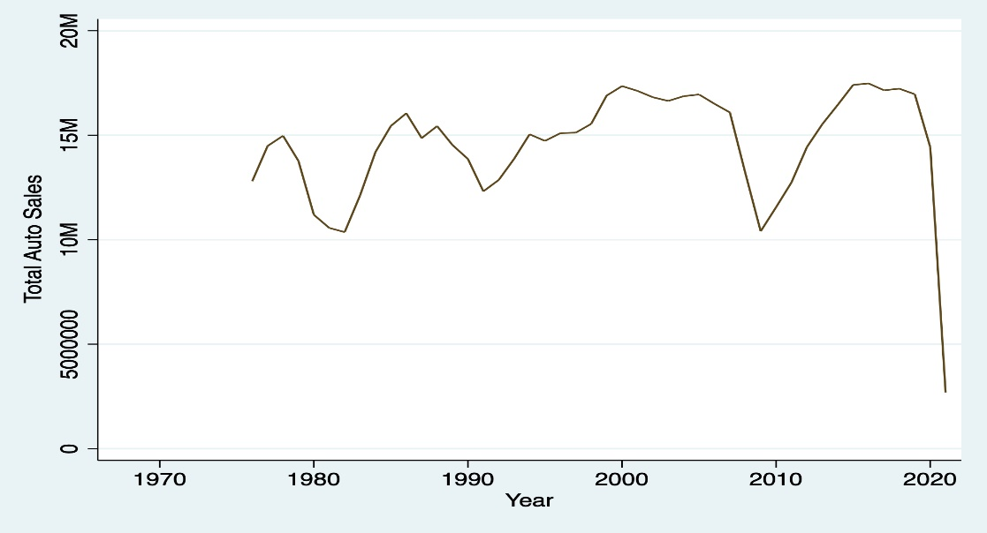

G2. Total Auto Sales

From graphG2, we can see that Total Auto Sales is seasonally trending. The seasonality’s can be due to several factors such as crisis for eg. The negative spike in 2008 is largely due to the Great Recession or in 2020 due to health crisis of Covid-19.

1. **Average Auto Price, Disposable Income & Unemployment Rate**

We collected the average auto price, disposable income and unemployment rate from the Bureau of statistics.

Regarding the Average Auto Price variable, we were able to retrieve only annual data. In order to continue with analysis, we assumed that the price when an auto is launched in the market remain constant through the years given adjustment for inflation. Therefore, the average annual average auto price coincides with the monthly average auto price in that particular year.



G3. Disposable Income & Average Auto Price

From the graph G3, we can clearly see that the average auto price is increasing above the disposable income. Possible causes are explored further in section4.

1. **Indexes**

We collected the data for –

* Durable goods consumer price index (acpi)
* Automobile & Light Trucks Producer Price Index(appi)
* Public Transportation Price Index(ptcpi)
* Motor Vehicle Insurance Price Index(mvicpi)

The Bureau of Statistics releases only the indexes based on actual data collected from surveys. Even though actual data would be better, but it is very difficult to find it for this type of research, the indexes serve as a good proxy and we were able to use them simultaneously having the same base year in 1982.



G4. Indexes Graph

From graph G4, we can say that the Durable goods consumer price index (acpi) is almost constant, the Automobile & Light Trucks Producer Price Index(appi) is slightly increasing. The Public Transportation Price Index(ptcpi) is also rising at a higher rate than the appi. The Motor Vehicle Insurance Price Index(mvicpi) is increasing exponentially. The insurance companies determine the prices based on several factors such as the car prices. As the car price increase the insurance could increase and this would make the affordability of the car more difficult. This is an interesting aspect from policy point of view which needs a further study.

**Chapter 3**

**Demand Estimation and Price Elasticity**

1. **OLS (Ordinary Least Square) Model**

We are interested in estimating the causality of a set of variables in the total passenger car sales in the US. In order to do so we need to build a model based on past data following the below formula

$$y_{t}=γx_{t-1}+ε$$

where $y_{t}$ is the raw data of auto car sales on time t, $x_{t-1}$ is the combination of raw data of predictors on time t-1 and $γ$ is the coefficient for each random variable.

The main purpose of this project is to find the relationship between the variables that allows us to make inferences about and possibly predict future demand.

The model equation is as follows –

$$Total Sales=β_{o}+β_{1}(aap)+ β_{2}(agp)+β_{3}(dis_income)+β_{4}(acpi)+β_{5}(ptcpi)+β_{6}(mvicpi)+β_{7}(appi)+β_{8}\left(pop\right)$$

Despite fitting Ordinary Least Squares model, it is necessary to fit the time series model since one of the assumptions underlying ordinary least squares (OLS) model is that the error terms are independent. This assumption is easily violated for time series data, such as this one since it may have pattern in quarters and years. Therefore, we found that the error terms have autocorrelation.

1. **Time Series Model**

In order to build an accurate time series model, we need to check white noise through Portmanteau test for each variable, having all the variables the p-values smaller than the significance level (95%), we can reject the null hypothesis and conclude that each variable is not a white noise. Second step we performed series of test for unit roots(stationarity) through Augmented Dickey Fuller Test. We find out that only 3 variables had not unit roots (Unemployment rate, Automobile & Light Trucks Producer Price Index appi, Durable goods consumer price index acpi). To resolve this issue, we adopted log log transformation for both dependent and independent variables. Log log model allows us to normalise the data and stabilise the variance. We believed that some variables such as disposable income would have a “retarded” effect on the total sales. To capture this assumption, we applied a multiple test to choose the correct number of lags for the model. Following the results, we opted AIC(Akaike Information Criteria) no. of lags since we are dealing with monthly data. We found out through Breusch Godfrey test that autocorrelation is persistent in our data. The last thing is to check the cointegration. We have performed Johansen Cointegration Test and found that the rank is 5. The cointegration test is performed to understand the long run relationship between the variables. Based on the results we decided best theoretical model for our analysis is Vector Error Correction Model with restricted trend and 4 lags. We have checked the model by performing residual, normality and stability test.

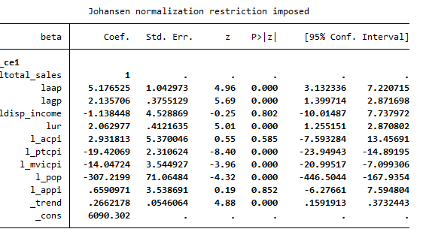

Tab.1 – Long Run Results

**Model Results**

As per the results obtained from Cointegration Test we chose to use Vector Correction Model. From Johansen Test we found that the rank is 5 which implies that 5 cointegrating equations are present in the model. The equation for Vector Error Correction Model is as follows -

$$x_{t}= φ_{1}x_{t-1}+⋯⋯⋯⋯⋯⋯+φ_{p}x_{t-p}+ε_{t}$$

$$∆x_{t}= πx_{t-1}+ \sum_{i=1}^{p-1}{φ_{i}^{*}}∆x_{t-1}+ ε_{t}$$

where $π$ and $φ_{i}^{*}$ the are functions of the $φ$. Specifically,

$φ_{j}^{*}=$ $-\sum_{i=j+1}^{p}{φ_{i}}$, j= 1……,p-1

$$π= -\left(I-φ_{1}- ⋯⋯- φ_{p} \right)= - φ(1)$$

where $π$ is the rank of cointegration. If it is 0 then there is no cointegration.

1. **Short Run -**

Average Auto Price (aap) is not significant as previous studies found out. The gasoline price(agp) is significant in the first 2 lags but it changes the sign for first lag it is negative and for second lag it is positive this implies that gasoline price is not a good predictor in the short run as it is unpredictable. This make sense because there are fluctuations in the raw oil due to several external factors like wars, stock market. The disposable income is significant only for 3rd lag meaning that the rise in the income is reflected in rise of total sales after 3 months at least. The Public Transport consumer price index has positive significant effect on the sales. However, the unemployment rate, durable good consumer price index(acpi), Motor Vehicle Insurance Consumer Price Index(mvicpi), Population, Automobile and Light Truck Producer Index(appi) have no significant effect on the sales.

1. **Long Run –**

Through Johansen Normalization Restriction, we can infer the long run relationship between the independent variables and total sales. As we expected, the average auto price is significant and negatively correlated meaning that with the rising of the prices we would observe a decline in the total sales (following the Demand & Supply Law). The fact that the average gasoline price is significant and negatively correlated could be interpreted as an attitude of the consumers towards more economic choices like public transportation, specially when combined with unemployment rate. The disposable income coefficient, despite being not significant, shows us that favourable economic conditions would lead to an increase in new vehicle sales. Regarding the indexes, the Public Transportation(ptcpi) and Insurance(mvicpi) has a proportional effect, but these could be due to same trend effect.

**Price Elasticities**

As we have followed the log log model, the elasticities are given by the coefficients of the model. We found that Price Elasticity is -5.17 which is more than 1, signifying it is elastic. On the contrary, the automobile long run elasticity is found inelastic as the change in the price will not reflect as much change as in the demand of the product in the past studies. In other words, in automobile industry this translates the fact that in the modern era cars are fundamental need of people and therefore consumer will buy the car irrespective of the price. However, in our study we found out that people would not buy the same amount of product or service whether the price drops or rises. These aspects should be deeply investigated in the future studies.

**Chapter 4**

**Considerations & Implications**

In this section, we will tackle the two main reasons behind this research: price and interest rate. While we investigated only the first aspect, here we explain why interest rate should be a fundamental aspect in future studies.

**Why are Car prices rising?**

A major driver behind the higher sticker prices on today’s cars is the increasing number of features consumers expect on their new vehicles. With the term feature we define a broad category of accessories not limited only to power windows, alarm system, air conditioning and radio but also the more recent technology such as infotainment, screens and driver assistance devices. In-car entertainment technology has evolved from simple, cheap radios to sophisticated infotainment systems with large display screens and advanced wireless connectivity. Most cars come standard with the ability to receive satellite radio. More sophisticated models have cellular-based data connections that receive real-time traffic, weather, and navigation information.

Furthermore, consumers are not just demanding longer feature list; there has been a dramatic shift from compact and mid-size cars to SUVs and light trucks. The bigger size involves that modern cars have also more power.

There is no doubt that today’s cars are safer than they ever have been. Many of the advances have been driven by regulation, while others have been driven by consumers. Nearly every aspect of your vehicle's safety system is subject to scrutiny by the federal government or other regulators. They dictate everything from the distance between a car's daytime running lights and its turn signals to requiring rear view cameras, stability control, and airbags. They set standards for the type and strength of child seat anchors. Regulations about pedestrian safety dictate the front-end design of today’s motor vehicles. The National Highway Traffic Safety Administration (NHTSA) does not only crash tests vehicles and reports the results to consumers; it also collects information about vehicle defects and works with manufacturers on product recalls. Complying with the ever-changing landscape of regulations is a significant expense for automakers, and those costs are passed along to consumers in the sticker prices of new cars.

Another important aspect is fuel economy and emissions. Many of the strides we have seen in fuel economy have been driven by government regulation. Fuel economy standards are developed by the NHTSA along with the EPA and the California Air Resources Board (CARB). The EPA and CARB are involved in setting the standards because greenhouse gases are directly tied to fuel consumption. Infact, these aspect drives the design and the used materials as well. Modern cars look different from old cars and that is not just a matter of style but also of aerodynamics. Now a days manufacturer utilize different materials such as aluminium and carbon fibre to diminish the weight in order to perform better.

All these factors contribute to the rise of the prices as the cost for research and development, raw materials and third-party technology cost more and more. Infact, the average profit margin is around 4% in the industry.

**Role of Interest Rate & Loans**

If prices are rising, how can the average household afford a new vehicle? “Finance and leasing products are well established in the US. Most consumers have access to credit and are familiar with traditional financing options. Car loans are the most popular purchasing method, accounting for almost 99 percent of car sales. But with lenders increasingly promoting leasing, this form of financing has gained momentum during 2010, especially in the luxury car segment. For some captives, the proportion of leasing contracts even exceeds the proportion of finance agreements. Despite this recent development, the overall penetration of leasing is only around 11 percent, which is one reason banks do not usually provide leasing contracts” (KPMG). The ongoing change in the automotive business model towards electrification, coupled with an increasing demand for mobility solutions such as car-sharing, and the saturation of Western markets, means that captives have to develop new markets.

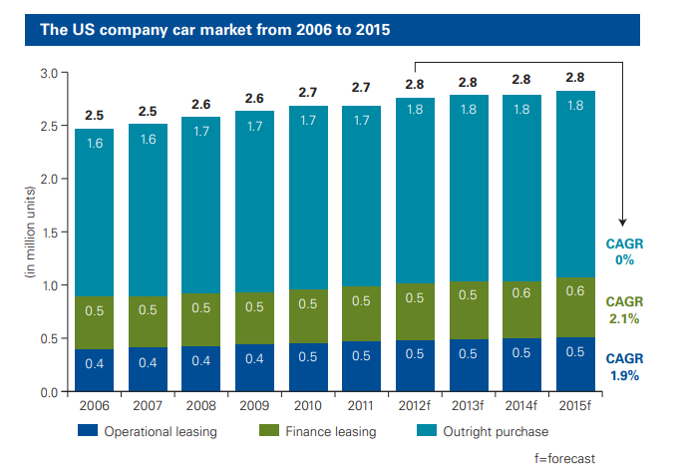

Fig5. US Company Car market (Operating Leasing, Finance Leasing & Outright Purchase)

In order to further satisfy their customers’ needs, OEM captive (Financing units wholly owned and operated by automotive companies) initially tried engaging with them after a car was purchased. They refined their finance and leasing products and developed special service and insurance packages. In addition, they even went beyond the traditional automotive value chain and tapped into the banking business to get access to low-cost funding and reach more customers.

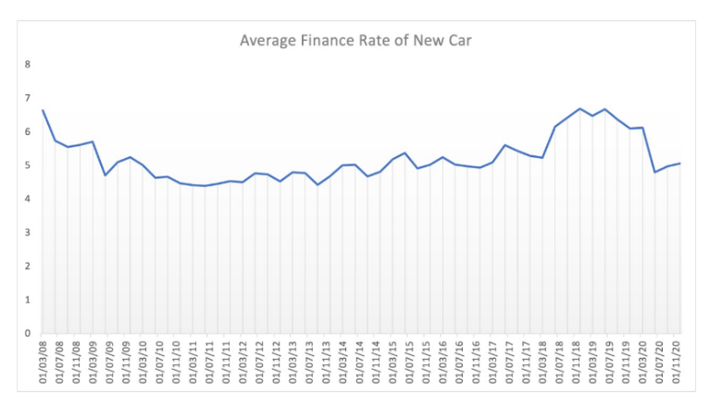

Fig6. Average Finance Rate of New Car

Longer-term loans carry risks. The Consumer Financial Protection Bureau warns that borrowers who take out long-term loans end up paying more for the car overall, and also run a greater risk of being “upside down” on the loans, meaning owing more than the car is worth.

Even if highly easily accessible loans enable households to buy a new car, higher and higher interest rates and long-term contracts could constitute a financial trap (fostered by asymmetric information in the market). This aspect should be the subject of stricter regulations from the government.

**Conclusions & Limitations**

**Limitations of our study & Recommendation for future Research**

The main limitations of our study are two 1) The average of car and light trucks price and 2) the magnitude of our model. We were able to gather data only for annual average prices of car and light trucks. In order to proceed with our research, we made the strong assumption that monthly average auto prices would be equal to Annual Average divided by No. of Months. The fundamental difficulty in deriving a price variable for the model is that "the actual sales price or transactions price" between the auto dealer and the consumer is an unknown figure. While actual sales prices do exist in the files of state revenue offices, the costs of extracting this information make it virtually inaccessible. We would recommend building a price function in order to correctly estimate the monthly average auto prices.

An ideal Demand function would include a series of variables that need to be calculated that we omitted. For Example, Used Car and Automobile Stock is needed to capture the alternatives for the consumers. In addition, a dummy for the ownership of a vehicle would help to estimate the choice of delaying the purchase of a new car. We performed a rudimental analysis considering the general landscape of the auto market in U.S; an improved version should divide the sales into brands and category of vehicles at the state level. Moreover, one can consider also categorical variables such as color and size. Another strong limitation of our model was the use of indexes instead of actual variables; ideally functions to capture the trends in those variables should be created. The best method to do so is to conduct surveys. Lastly to be more accurate discretionary income which is the money that an individual or a family has to invest, save, or spend after taxes and necessities are paid, would be a better variable to predict the sales trend.

**Conclusions**

The aim of this paper is to lay the foundation for future studies to deepen the thematic related to the demand of new autos. Firstly, the population growth trend, the mileage growth trend and the number of vehicle trend should concern the government regarding the pollution, the congestion, the safety and the development of new roads. A greater and greater no. of vehicles considering also all the vehicles represent a big challenge for the environment regulations.

While cars have transformed the economic world, they have also transformed our natural environment. The exhaust from cars contributes to air pollution, which is hazardous to health. Car exhausts are a source of greenhouse gas emissions and thus contribute to climate change.

Pollution from cars is a classic example of an **externality**. An individual’s decision to purchase and drive a car does not consider the effects on third parties. In this case, some of the affected third parties are those in the immediate vicinity who suffer from a reduction in air quality. To the extent that emissions contribute to climate change, however, the third parties potentially include everyone in the world.

Governments in the United States and elsewhere have enacted various policies that are motivated, at least in part, by the desire to consider such environmental externalities and resource use. First, there are taxes on gasoline. These are relatively low in the United States but are much higher in Europe. Second, there are technological restrictions, such as the requirement that automobiles be fitted with catalytic converters and designed to run on unleaded fuel. In the United States, the government has taken action to improve the fuel consumption of cars produced within US borders.

1. the restrictions are in terms of fuel economy (miles per gallon), and (2) the restriction does not apply to individual automobiles but rather to the set of cars sold by a corporation.

All these restrictions have led to continuous technology improvement, nonetheless these efforts are having little improvement on global environmental situation.

Road Congestion is another example of an externality. The decision of one person to drive has an effect on other drivers. Congestion represents problem not only for the environment but also for the economy as slower road results in lower productivity. One way of solving externally problems is to create new markets. In most cases, there is no market for the use of road. However, if we charge people to use roads, then market incentives come to play. Toll roads are an example of the introduction of a market mechanism to combat congestion problem.

A less imminent issue is the creation of roads as the number of vehicles is rising and this will be a challenge for optimal decisions as the government has to consider several variables such as the land dedicated to agriculture.

Another concern is the relationship between the prices, the income and the interest rates in that it could create a vicious circle that can pauperize even more poor households. A possible counter measure to this phenomenon is to improve the current public transportation services and incentivise the sharing economy.

**Appendix**



Fig.7 Unemployment Rate Growth



Fig8. Population Growth



Fig9. Average Auto Price Autocorrelation



Fig10. Average Car Price Index



Fig11. Average Gasoline Price Autocorrelation



Fig12. Average Producer Price Index Autocorrelation



Fig13. Disposable Income Autocorrelation



Fig.14 Motor Vehicle Insurance Consumer Price Index Autocorrelation



Fig. 15 Public Transport Consumer Price Index - Autocorrelation



Fig.16 Total Sales Autocorrelation



Fig.17 Unemployment Rate Autocorrelation

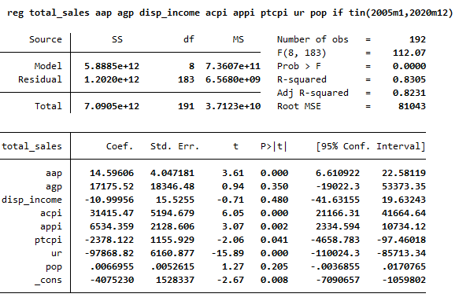

Table 2. OLS result



Fig18. Scatter Plot – OLS Residuals



Fig 19. Histogram Plot – OLS Residuals

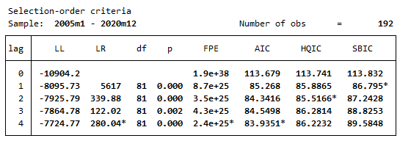

Table 3. Lag Selection Order Criteria Result

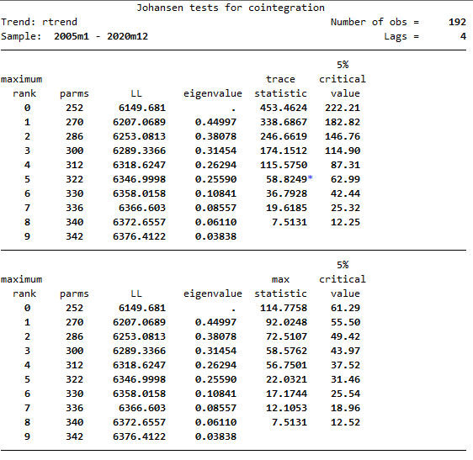

Table4. Johansen Cointegration Test Results

**Vector Error Correction Equation for variables -**

$$∆{Total Sales}_{t}=π{Total Sales}_{t-1}+ \sum_{i=j+1}^{p}{φ_{i}^{*}}∆{Total Sales}_{t-i}+ ε_{t}$$

$$∆{aap}_{t}=π{aap}_{t-1}+ \sum_{i=j+1}^{p}{φ_{i}^{*}}∆{aap}_{t-i}+ ε_{t}$$

$$∆{agp}_{t}=π{agp}_{t-1}+ \sum_{i=j+1}^{p}{φ_{i}^{*}}∆{agp}_{t-i}+ ε_{t}$$

$$∆{disp_income}_{t}=π{disp_income}_{t-1}+ \sum_{i=j+1}^{p}{φ_{i}^{*}}∆{disp_income}_{t-i}+ ε_{t}$$

$$∆{ur}_{t}=π{ur}_{t-1}+ \sum_{i=j+1}^{p}{φ_{i}^{*}}∆{ur}_{t-i}+ ε_{t}$$

$$∆{acpi}_{t}=π{acpi}_{t-1}+ \sum_{i=j+1}^{p}{φ_{i}^{*}}∆{acpi}_{t-i}+ ε_{t}$$

$$∆{ptcpi}_{t}=π{ptcpi}_{t-1}+ \sum_{i=j+1}^{p}{φ_{i}^{*}}∆{ptcpi}_{t-i}+ ε_{t}$$

$$∆{mvicpi}_{t}=π{mvicpi}_{t-1}+ \sum_{i=j+1}^{p}{φ_{i}^{*}}∆{mvicpi}_{t-i}+ ε_{t}$$

$$∆{appi}_{t}=π{appi}_{t-1}+ \sum_{i=j+1}^{p}{φ_{i}^{*}}∆{appi}_{t-i}+ ε_{t}$$

$$∆{pop}_{t}=π{pop}_{t-1}+ \sum_{i=j+1}^{p}{φ_{i}^{*}}∆{pop}_{t-i}+ ε_{t}$$

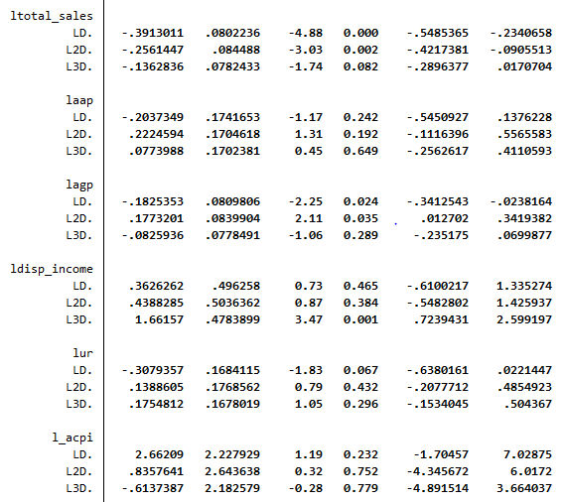

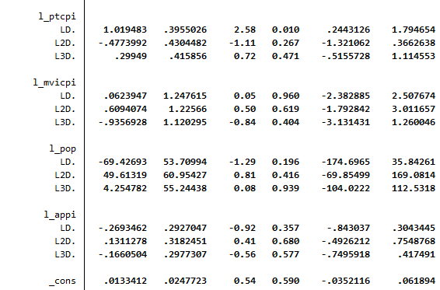

Table 5. VEC Model - Short Run Results

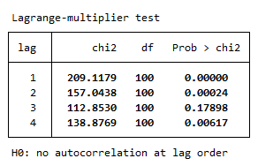

Table 6 – VEC Model - Autocorrelation Results

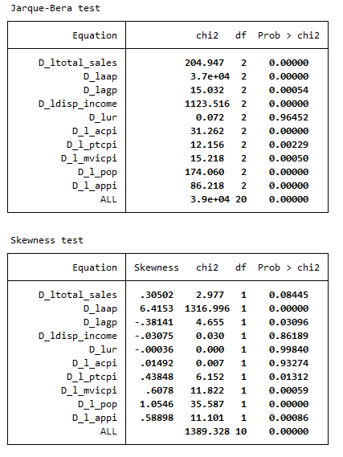

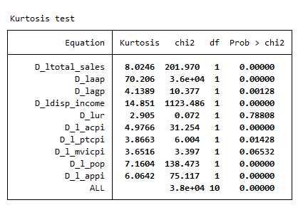

Table7 – VEC Model - Normality Test

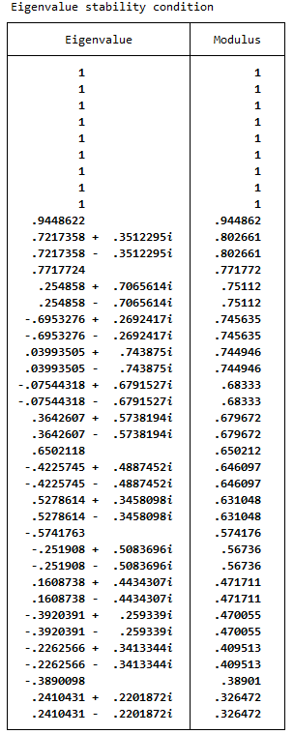

Table8 – Stability Test



Fig 20. VEC Model - Stability Plot

**Stata Do File**

/Generating Total Sales as a combination of all the sales

generate total_sales = das+fas+dltas+fltas

generate disp_income = di

//Setting the time

generate time = tm(1970jan)+_n-1

tsset time, monthly

//Autocorrelation Graphs of Variables

ac total_sales in 457/648

ac aap in 457/648

ac agp in 457/648

ac disp_income in 457/648

ac ur in 457/648

ac acpi in 457/648

ac appi in 457/648

ac ptcpi in 457/648

ac mvicpi in 457/648

//White Noise Test for variables

wntestb total_sales

wntestb aap

wntestb agp

ipolate agp time, generate(agp2)

replace aap = 40107 in 637

wntestb disp_income

wntestb ur

wntestb acpi

wntestb appi

wntestb appi

wntestb ptcpi

wntestb mvicpi

wntestb pop

//OLS Regression

reg total_sales aap agp disp_income acpi appi ptcpi mvicpi pop ur if tin(2005m1,2020m12)

//Predicting the Residuals

predict e_ols, resid

predict res_ols

//Plotting the residuals

twoway scatter e_ols res_ols

//Unit Root Test for residuals

dfuller e_ols1, lag(10)

dfuller d.e_ols, lag(10)

estat dwatson

estat durbinalt

estat bgodfrey

//Generating log of variables

generate ltotal_sales = log(total_sales)

generate laap = log(aap)

generate lagp = log(agp)

generate ldisp_income = log(disp_income)

generate lur = log(ur)

generate l_acpi = log(acpi)

generate l_ptcpi = log(ptcpi)

generate l_mvicpi = log(mvicpi)

generate l_pop = log(pop)

generate l_appi = log(appi)

//Test for Lag Selection(AIC) and Cointegration

varsoc total_sales aap agp di ur acpi appi ptcpi pop disp_income

//Vector Error Correction Model

vec ltotal_sales laap lagp ldisp_income lur l_acpi l_ptcpi l_mvicpi l_pop l_appi, trend(rtrend) rank(1) lags(4), if tin(2005m1,2020m12)

//Perform Some Diagnostic Test

//1) Autocorrelation Test

veclmar, mlag(4)

//2) Normality Test

vecnorm, jbera skewness kurtosis

//Stability Test

Vecstable

**References**

* Federal Reserve Bank of St. Louis <https://fred.stlouisfed.org/>
* Bureau of Transportation Statistics <https://www.bts.gov/>
* Bureau of Economic Analysis <https://www.bea.gov/>
* U.S Bureau of Labor Statistics <https://www.bls.gov/>
* A Disaggregate Model of the Automobile Market: the Demand for Cars of Different Sizes by Rodnet Lee Carlson <https://digitalcommons.lsu.edu/cgi/viewcontent.cgi?article=3912&context=gradschool_disstheses>
* Auto Sector - Forecasting Automobile Output <https://www.newyorkfed.org/medialibrary/media/research/quarterly_review/1985v10/v10n4article7.pdf>
* Auto Car Sales Prediction: A Statistical Study Using Functional Data Analysis and Time Series by Yuchen Lin <https://deepblue.lib.umich.edu/bitstream/handle/2027.42/112123/lycumich.pdf?sequence>
* Estimating Demand for Automobile Industry in the U.S Market 2010-13 by Xiaonan Qin <https://repository.library.northeastern.edu/files/neu:349589/fulltext.pdf>